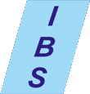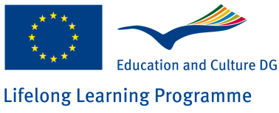

**Further information on www.alma-dc.eu**

The objectives of the project are to develop an interactive learning course for migrant women and to create innovative pedagogical guidelines for teachers/trainers in adult education.

IBS - Institut für berufliche Bildung und EDV Schulung GmbH

Cottbuser Str. 4

01979 Lauchhammer

**Develop**

**Skills**

**Gain Employability**

**Adult**

**Learning**

Under the EU-funded Grundtvig project, ALMA-DC, the European Countries **Greece, Czech Republic, Germany, Italy, Spain, Slovakia, and Romania** are collaborating for the development of strategies and methods to support the employability of marginalised and disadvantaged people.

This project has been funded with support from the European Commission

**Adult Learning for MArginalised and Disadvantaged Citizens**